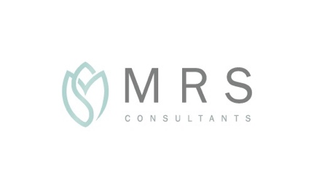

ISLAMIC MARRIAGE GUIDE



“And one of His signs is that He created for you spouses from yourselves that you may find tranquility in them, and He has ordained between you affection and compassion. Surely in this are signs for people who reflect.” (Holy Quran, 30:21)

What’s included in our Islamic Marriage Package

* Online/in-person consultation with scholar to discuss your needs and to answer any questions you have [45mins]
* Complimentary online coaching session with professional clinical psychologist (optional) [45mins]

This can be a lot of fun especially if you attend as a couple. It’s a great way to pick up some tips and to help you both set some relationship goals.

* Islamic marriage ceremony (Nikah) at a time and location of your choice – online/remote option available
* Islamic marriage certificate (in English)
* In-person consultations and ceremonies are currently offered in London and Brighton. Other locations available on request.

Our Fees

Our fees start at £200 and depend on the proposed location of your ceremony

Email us at [contact@MRSConsultants.co.uk](mailto:contact@MRSConsultants.co.uk) or via our contact form for a fee quote. Please include details of the proposed location and date for your ceremony

Payment plan

* £100 on application
* Balance due 2 weeks before the ceremony date

Payment methods

For secure card processing through Stripe, use our payment portal and enter the amount due

To pay via bank transfer or in cash, please email us at [contact@MRSConsultants.co.uk](mailto:contact@MRSConsultants.co.uk)

How to get started and what to expect

Step 1

Email us at [contact@MRSconsultants.co.uk](mailto:contact@MRSconsultants.co.uk) or via our contact form to let us know where and when you would like your ceremony to be held

Our team will send you a fee quote shortly after

For urgent bookings, call us on ( )

Step 2

If you are happy with the fee quote, please complete our Islamic Marriage Form

£100 is payable on application (this is non-refundable)

Step 3

You will be invited to schedule a consultation with our scholar, and a complimentary session with our coach (optional)

Step 4

Please arrange payment of the balance within 2 weeks of your ceremony date

Our team are always available if you need to get in touch [contact@MRSConsultants.co.uk](mailto:contact@MRSConsultants.co.uk)

Changes and Cancellations

We understand that sometimes plans change. That’s why we’ve tried to be as flexible as possible.

Changes/cancellations made 2 weeks or more before your ceremony date are permitted without charge. Please email us to let us know

Location changes may incur additional charges

Cancellations made within 2 weeks of your ceremony are non-refundable

Changes made within 2 weeks of your ceremony are subject to availability and are non-refundable

Contact

Phone 123345678

Email contact@MRSConsultants.co.uk

Important

Scholars at MRS Consultants reserve the right to refuse to perform the Nikah ceremony if Sharia requirements are not met or if there are any concerns over consent.

An Islamic marriage ceremony that takes place in the UK is considered a religious ceremony. To have a legally valid marriage in the UK, you will also need to have a civil ceremony, for example at a Registry Office.

This guide is designed to give you a simple overview of our Islamic Marriage service. It is not intended to replace professional religious or legal advice that is tailored to your specific circumstances.